Celebal Summer Internship 2026

Week 6: Spark Assignment

Submitted by : Shauryansh chauhan (MMDU)
Roll no .:11232836
Course: B.Tech Computer Science & Engineering
Assignment of week 6

Q1: Explain the roles of the Driver, Cluster Manager, and Executor in a Spark application.
Ans:
Driver: The "brain" of the application. It runs your main() code, creates the Spark Session, converts your code into a plan (DAG), and breaks the work into smaller tasks.
Cluster Manager: The "allocator." It watches the physical hardware resources and hands out worker machines to your application (e.g., Standalone, YARN, Kubernetes, or Databricks' internal manager).
Executor: The "muscles." These are individual worker processes running on cluster nodes that actually execute the tasks assigned by the Driver and store data in memory/disk.

Q2: How does Spark’s Lazy Evaluation strategy improve performance when chain-processing large datasets?
Ans:
Spark doesn't run operations immediately when you type them. Instead, it builds a recipe (Lineage Graph). When you finally ask for the result (an Action), Spark's Catalyst Optimizer looks at the whole recipe at once. It optimizes the plan—like combining filters or skipping unneeded columns—preventing temporary data from clogging up memory and reducing expensive network data transfers.

Q3: Write a Spark command to read a CSV file located at "data/source.csv", ensuring the first row is treated as a header and inferSchema is enabled.
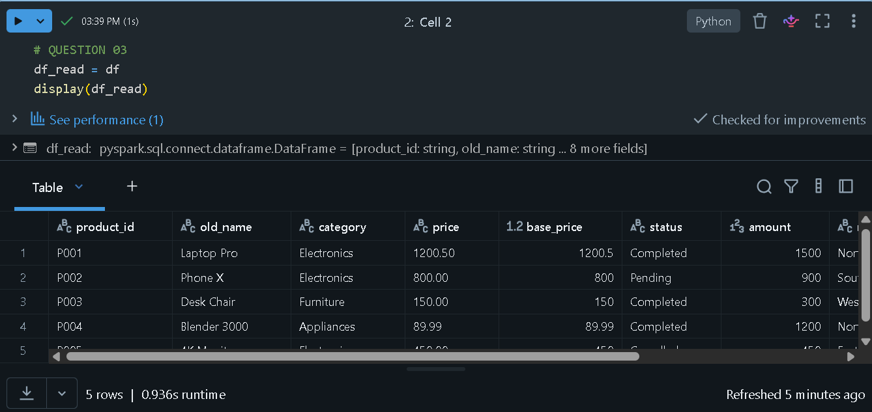

Q4: What is the difference between CSV and Parquet in terms of storage (row-based vs. columnar) and why does it matter for performance?
Ans:
CSV : Stores data line-by-line. To read just one column (e.g., price), Spark has to read every single row and every single column on disk.
Parquet : Stores data column-by-column. If you only need the price column, Spark skips everything else on disk entirely. It also compresses identical values within a column beautifully, saving massive disk space and massive network I/O.

Q5: Given a DataFrame df, write a query to select the columns product_id and price where the category is 'Electronics'.
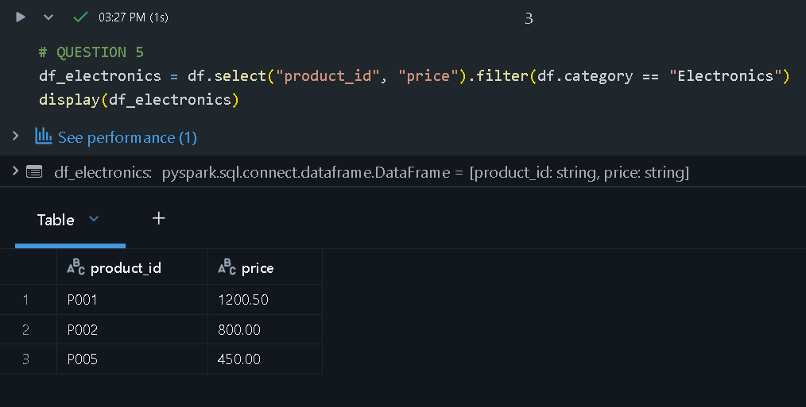
Q6: Write the code to "revise" a DataFrame by renaming the column old_name to new_name and casting the price column from a String to a Double.
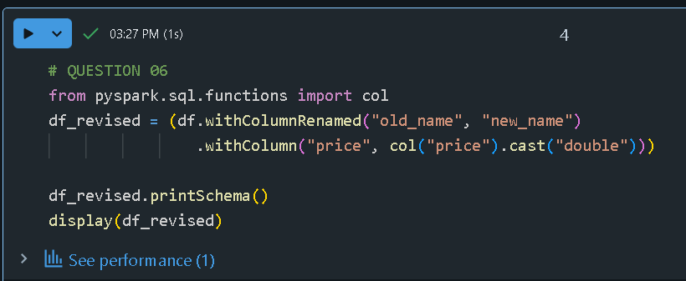

Q7: How does Spark use the Lineage Graph (DAG) to provide fault tolerance if a worker node fails?
Ans:
Because Spark tracks every step used to build a DataFrame in a Lineage Graph (DAG), it doesn't need to duplicate data across multiple machines for backup. If a worker node crashes and loses its data partitions, the Driver simply looks at the DAG recipe and re-computes only those missing partitions on a healthy worker node from the original source files.

Q8: Write a query to filter a DataFrame df_orders for rows where the status is 'Completed' AND the amount is greater than 1000.
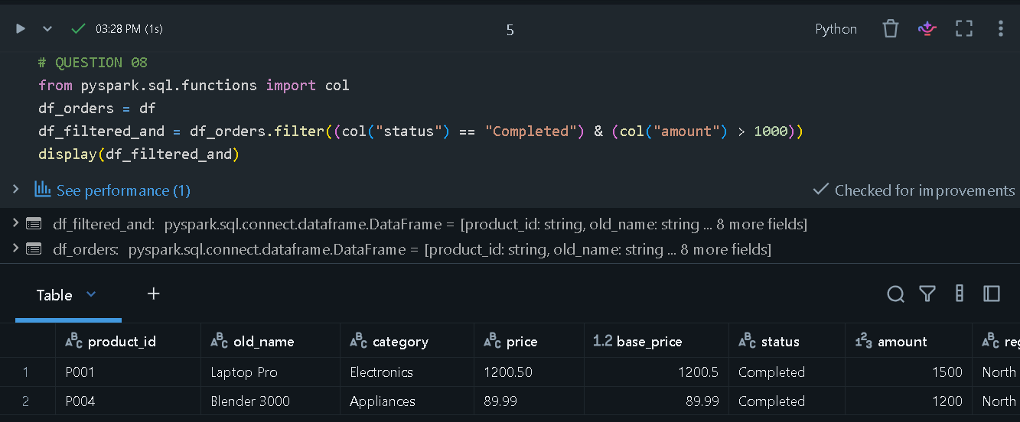

Q9: Explain the concept of Predicate Pushdown in Parquet and how it affects the amount of data loaded into memory.
Ans:

Parquet files contain metadata packets that store the minimum and maximum values for every block of data. "Predicate Pushdown" means Spark "pushes" your filter conditions (like WHERE age > 30) down to the file storage layer. If a block's metadata says its max_age is 25, Spark skips reading that entire block of data off the disk, saving immense memory and processing power.

Q10: Write a code snippet to add a new column final_price which is the base_price multiplied by 1.18 (18% tax).
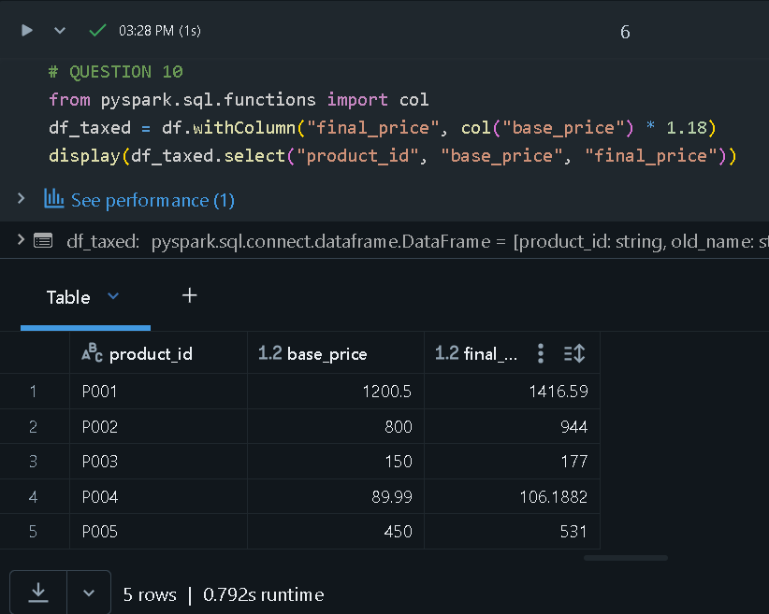

Q11: What is the difference between Transformations and Actions? Provide two examples of each.
Ans:
Transformations: Lazily evaluated operations that create a new DataFrame from an existing one without moving data.
- Examples: .filter(), .select(), .withColumn(), .groupBy()
Actions: Operations that trigger the actual computation by forcing Spark to execute the DAG and return a result.
- Examples: .count(), .show(), .collect(), .write.save()

Q12: Write the Spark command to load a Parquet file from "path/to/input", filter out any rows where user_id is null, and save the result as a CSV at "path/to/output".
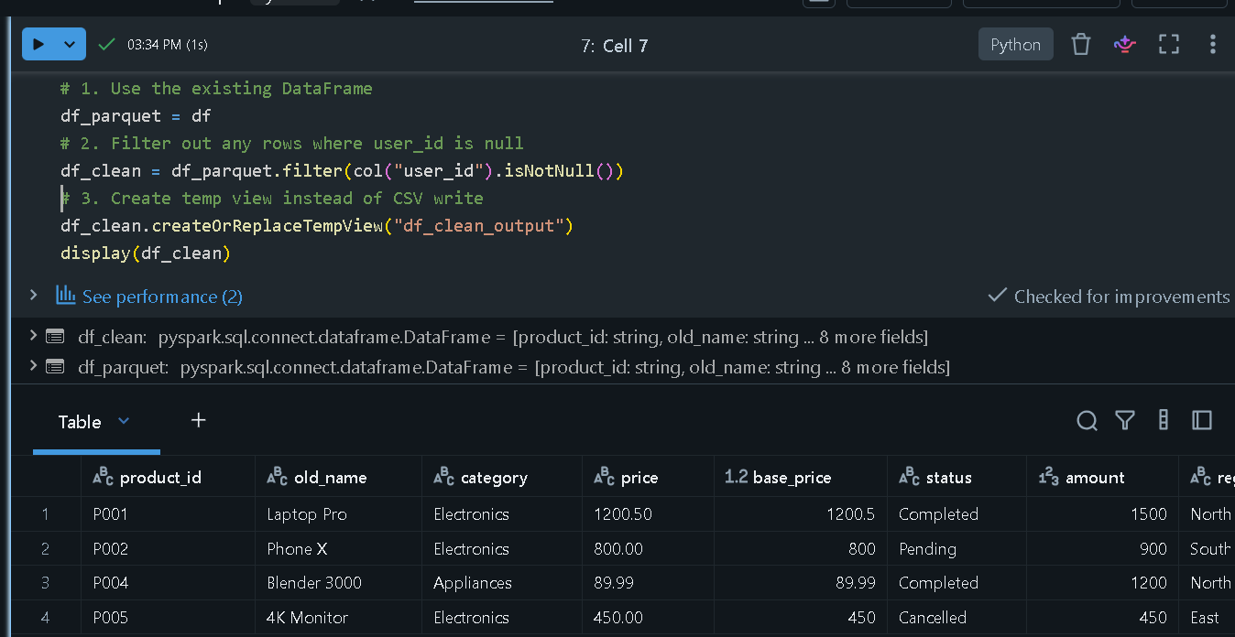
Q13: In Spark Architecture, what is the difference between Client Mode and Cluster Mode?
Ans:
Client Mode: The Driver process runs locally on the computer where you submitted the script (like your laptop). If your laptop disconnects or shuts down, the job dies.
Cluster Mode: The Driver process is handed off to a worker node inside the cloud cluster itself. You can close your laptop and walk away; the job will safely run to completion on the cloud infrastructure.

Q14: Write a query to filter a dataset for rows where the region is 'North' OR the priority is 'High'.
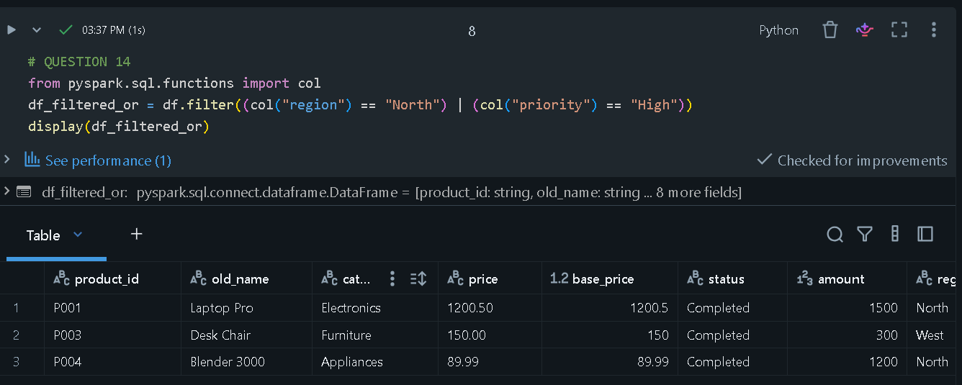

Q15: When exploring a dataset, why is it safer to use .show(5) instead of .collect() on a multi-terabyte dataset?
Ans:
show(5): Its only pulls exactly 5 rows from the executors to display on your screen. It uses practically zero driver memory.
collect() : Its forces Spark to fetch every single row across a multi-terabyte dataset and cram it all into the single memory space of your Driver node. This immediately triggers an Out of Memory (OOM) error and crashes your entire Spark session.

